File name: albuquerquegroup.jpg  The Albuquerque group, taken December 7, 1978: top row: Steve Wood, Bob Wallace, Jim Lane. Second row: Bob O’Rear, Bob Greenberg, Marc McDonald, Gordon Letwin. Front row: Bill Gates Andrea Lewis, Marla Wood, Paul Allen. Formal portrait of Microsoft employees before the company moved to Bellevue, WA. Rick Weiland and Miriam Lubow were not present for the photo. (Museum item # 62) | 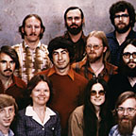
File name: altairwithbasictape.jpg  Altair 8800 minicomputer with computer punch tape; first manufactured in 1975. (Museum item # 48) | 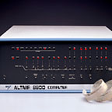
File name: ballmeroffice.jpg  Casual portrait of Steve Ballmer in his office, Bellevue, ca. 1980-1983. (Museum item #787) | 
File name: ballmerplunge.jpg  Steve Ballmer jumping into `Lake Bill` as a result of a challenge Mike Maples issued to Steve during the 1988 United Way campaign to see whose group could raise the most money, December 9, 1988. (Museum item #717) | 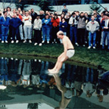
File name: basictape.jpg  Paper tape, the main storage medium at the time, with Bill Gates’ and Paul Allen’s first program on it – a BASIC language for the MITS Altair. | 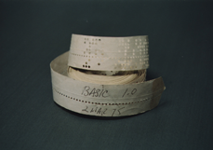
File name: billandsteve.jpg  Steve Ballmer and Bill Gates, ca. 1983 (Museum item #1794) | 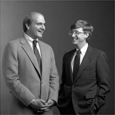
File name: billgates79-80.jpg  Casual portrait of Bill Gates in his office, Bellevue, ca. 1979-1980. (Museum item #969) | 
File name: campus.jpg  Aerial view of the Redmond Campus, ca. August 1989. (Museum item #727) | 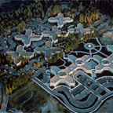
File name: excel1box.jpg  Excel 1.0 for the Macintosh box shot, ca. 1985. (Museum item #265) | 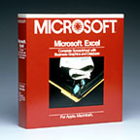
File name: excel3.jpg  Excel for Windows 3.0 box shot, 1991. (Museum item #59) | 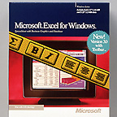
File name: excelformac.jpg  Excel 1.0 for Macintosh, screen shot, ca. 1985. (Museum item #3211) | 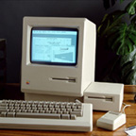
File name: Gatesandallen.jpg  Microsoft co-founders Paul Allen and Bill Gates surrounded by personal computers, shortly after signing a major contract with IBM to write software for their line of personal computers. This image is featured in the Seattle Business Journal’s October 19, 1981 article, “Building on success, Microsoft owners shoot for $100 million target.” (Museum item #45) | 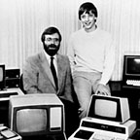
File name: ibmpc.jpg  IBM PC running Microsoft Word for MS-DOS, ca. 1983. (Museum item # 1652) | 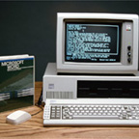
File name: Internetstrategyday.jpg  Nathan Myhrvold, Pete Higgins, Bill Gates, and Paul Maritz on stage at the Internet Strategy Workshop, held at the Seattle Center, December 7, 1995. (MicroNews December 15, 1995). At the Internet Strategy Workshop, held at the Seattle Center on December 7, 1995, Bill Gates outlined Microsoft`s wide-ranging commitment to supporting and enhancing the Internet by integrating the PC platform with the public network. Gates noted that businesses will adopt the Internet for internal business use-`the Intranet`-for communication with employees, suppliers, and customers, and Intranet applications will likely emerge faster than those for the general consumer market. (Museum item #619) | 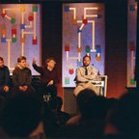
File name: Lakeside.jpg  Paul Allen and Bill Gates at an ASR-33 teletype in the computer room at Lakeside School, Seattle, WA, ca. 1968. (Museum item #3) | 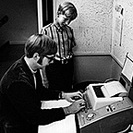
File name: Msdosad.jpg  Advertisement for MS-DOS 1.0, ca. 1981-1983. (Museum #291) | 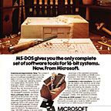
File name: office4box.jpg  Office 4.0 Standard Edition box shot, ca. 1993-1994. (Museum item #403) | 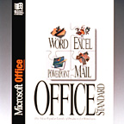
File name: officebox.jpg  Office 1.0 for Windows box shot, ca. 1990. (Museum item #407) | 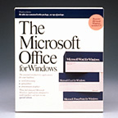
File name: popularelectronics.jpg  The January 1975 issue of Popular Electronics magazine featured the Altair 8800. The article about the Altair inspired Bill Gates and Paul Allen to develop a BASIC Interpreter for the Altair. (Museum item #2169) | 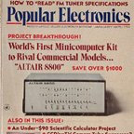
File name: tenthanniversary.jpg  In August 1985, Microsoft celebrates its 10th anniversary. This poster commemorates the company’s achievements and culture. Microsoft has $40 million in revenue and 900 employees. (Museum item # 58) | 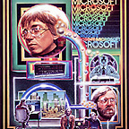
File name: Windows1box.jpg  Windows 1.0 for MS-DOS box shot. Shipped November 1985. (Museum item #47) | 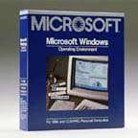
File name: Windows20001box.jpg  Windows 2000 box shot. Shipped February 2000. | 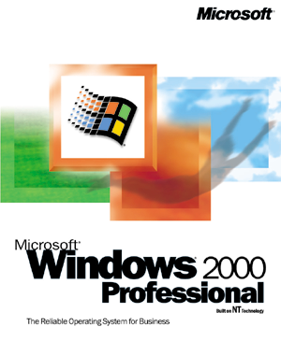
File name: windows2000box.jpg  Windows 2000 box shot. Shipped February 2000 | 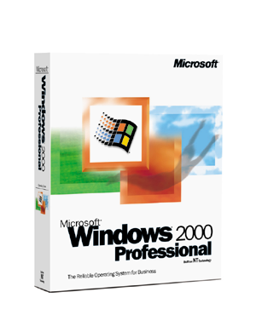
File name: Windows3.jpg  Poster advertising Windows 3.0, ca. 1990. (Museum item #108) | 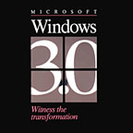
File name: Windows95box.jpg  Windows 95 Upgrade box shot, ca. 1995. (Museum item #398) | 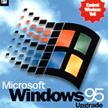
File name: Windows95launch.jpg  Bill Gates on stage at the Windows 95 Launch, held on the Redmond campus, August 24, 1995. (Museum item #2562) | 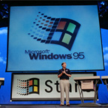
File name: windows95launch2.jpg  Brad Silverberg and Bill Gates on stage at the presentation for the Windows 95 Launch, held on August 24, 1995. (MicroNews August 25, 1995). (Museum item # 686) | 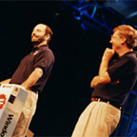
File name: windowsntbox.jpg  Windows NT 3.1 box shot, ca. 1993. (Museum item #244) | 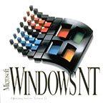
File name: Wordwithmouse.jpg  Advertisement for Word 1.0 for MS-DOS featuring the Green Eyed Mouse, ca. 1984. (Museum item #1666) | 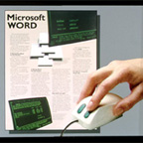
File name: MS_W_H_POS.gif  MSN Logos can be found in the folder labeled MSN Logos | 
File name: msft_25silver.JPG  25th Anniversary logos can be found in the folder named MS25 logos | 
File name: win2000-1 2-17.jpg  Windows 2000 launch shots can be found in the folder named Win2000 launch | 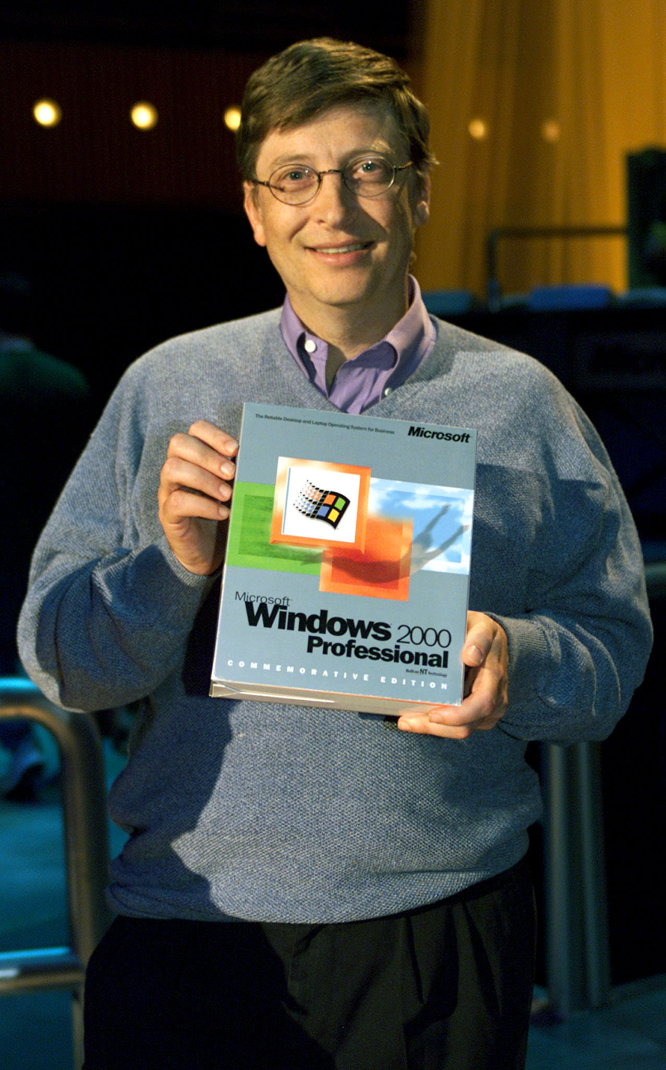
File name: NGWS new logo_rgb.jpg  .NET logo files can be found in the folder named dot net logo files | 
File name: bobbox.tif  Bob 1.0 for Windows box shot, circa 1995 | 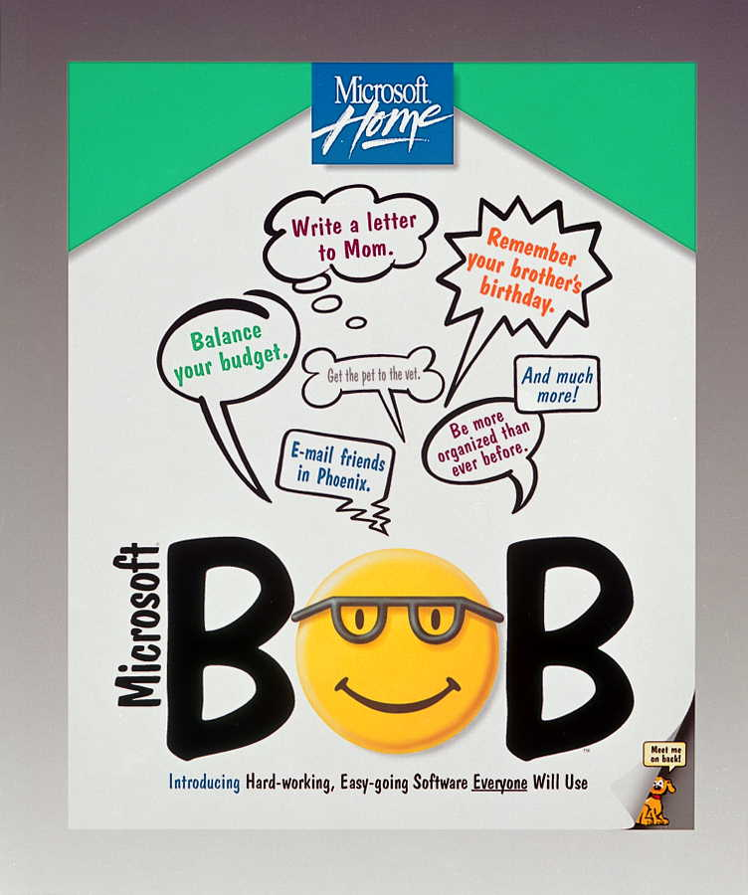
File name: Bibbetlogo.tif  The Microsoft logo, circa 1982-1986 | 
File name: logota~3.gif  The Microsoft logo and brand tagline can be found in the folder labeled logo with tagline | 
File name: billandpaul.tif  Paul Allen and Bill Gates standing in front of a white board, February 1982. Copyright for this image is held be the Seattle Times, if you are interested in using it, you MUST clear it for re-use rights. See this link for usage information: http://seattletimes.nwsource.com/news/general/copyright.html | 

