Tracker 2.0 Best practices

Data clean-up of License ‘over- registration’

With the migration of data from the old Tracker database, you may encounter some data quality issues. When checking for available licenses to register, you may find negative numbers in the “Qty Available” list. This is caused by the fact that more licenses were registered against the specific License and Order ID than were purchased on the particular Order ID.
The reason for this is that the original Tracker database allowed you to register more licenses against an order then the number of licenses purchased. The Tracker 2.0 release prevents you from registering more licenses than purchased.
A manual clean-up effort is required when you encounter some of these over-registrations.

In order to improve the data quality of the Tracker database and to ensure only the amount of licenses purchased on a Company’s account can be registered, you are requested to clean up the account.

When you are working on a Service Request related to a ClearCase product family license registration of License move, and encounter a negative quantity in the “Qty Available” field, locate the actual license string.

In the step-by-step instructions below, we will use the company Hewlett Packard as an example (in the example you may notice that the license string is for 28 licenses, please ignore this in these instructions. The example license string is already registered against multiple License ID’s).

This document describes the best practice for this manual clean up.

- Locate a license registration whereby the number of licenses registered is larger than the quantity of licenses purchased. You most likely identify these over-usage license registrations when working on a Service Request.

- Under the Tab ‘HostID’ in Tracker you have queried on a Hostid registration. After you located the host registration, you opened the Host detail page. On the host detail page you find under the header “Licenses purchased by Company” an overview of all licenses purchased and the amount of licenses registered against the different License and Order ID’s.
- If you locate a License ID and Order ID line whereby the ‘Qty available’ is showing a negative number, locate the actual license string registration under the header “Move hosts”
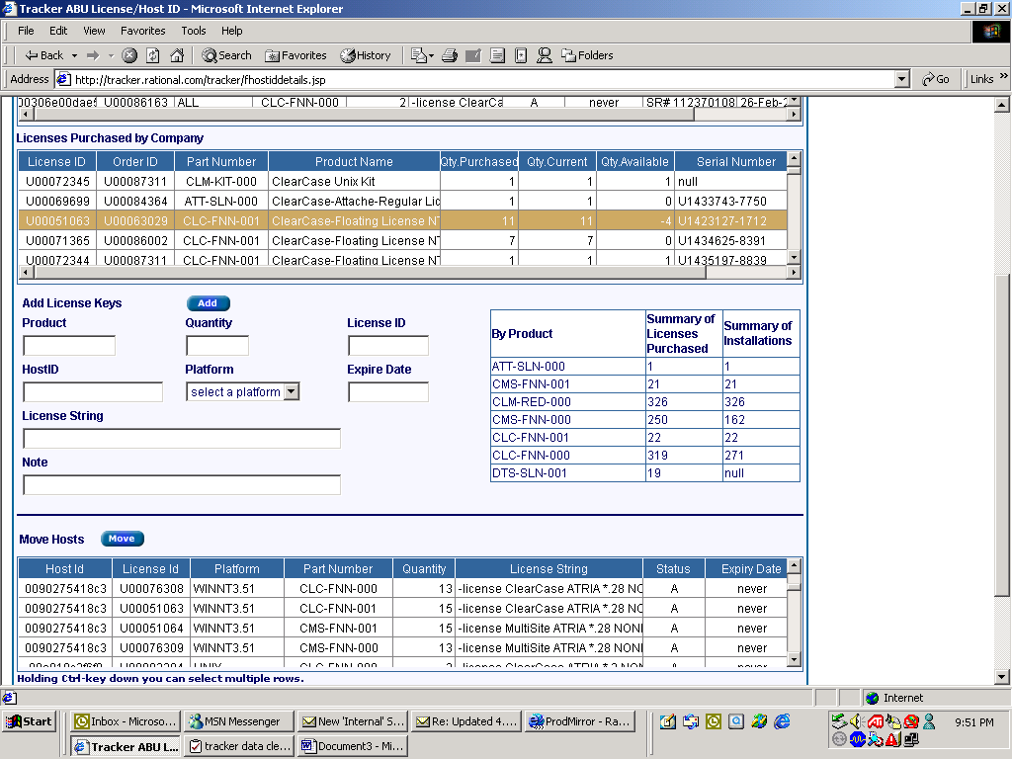

You notice that there are 15 licenses registered against License ID U00051063, with Order ID U00063029. On this Order ID, only 11 licenses were purchased, therefore the Quantity available shows –4.
To adjust this you will have to de-activate the license registration, move the license registration (status will become M = moved)

IMPORTANT!! Before you do this, you want to be able to capture the data in a format allowing you to copy and paste the host and license string details. The way to do this is to run a Company report.

On the Host detail screen you find the Company ID and company Name

- Copy this company name and change your view in Tracker to the ‘Company’ tab and run a Report using this Company Name.
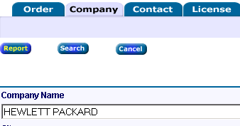

- Allow Tracker to build the report for you. You can save this report to your local computer. When saving the report change the format to Excel.
- Locate the license you are about to ‘Move’ (deactivate) on the report

- Go back to the ‘HostID’ tab in Tracker and locate your Host detail screen again. Simply search on the same details again as you did in Step 1.
- Now you can Move the actual license string and with doing that de-activate the license string. Ensure to de-activate or move licenses as described in chapter 7.2.2 or the Tracker manual.

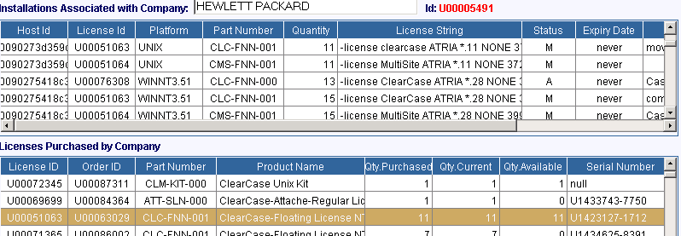

- Now Add the license registrations against another License ID and Order ID where there are available licenses. You could use the same License and Order ID as you just moved the license registration from + another License and Order ID, or you can use another License and Order ID with sufficient ‘Qty Available’
- To add the license string again, you use the details as listed in the company report. Copy and paste the Hostid and License string detail from the company report to the Host Detail screen. If you need to register the license string to more then 1 License ID, repeat your steps. Make sure to click the ‘Add’ button only once per license ID!! Make a note of the reason for the new license registration.



