IBM France Software Laboratory
Rational Enterprise Tools & Compilers
1, place Jean-Baptiste Clément
93891 Noisy-le-Grand Cedex

IBM Rational Software
Pacbase Convergence Plan
Environment Installation: RTCz Client Setup

1. Introduction 3
2. Prerequisites 4
3. Install the client 5
3.1 Installation 5
3.2 Configuration 6
4. Make a deliver 11
4.1 Prerequisite 1 11
4.2 Prerequisite 2 12
4.3 Deliver 13
5. Search on RTCz Server 19
5.1 Insights 20
5.2 Search 20
6. Browse artifacts via reference relationships 21

Introduction
The objective of this document is to help installing the different parts of the Repository RTCz Client.
It provides also a basic documentation on the delivery process, as well as an example of a "search" function and a browsing of artifacts.
In a context of a Pacbase Convergence Plan evaluation project, it will allow you to progressively discover the new integrated development platform and environment that will be used for the maintenance of Pacbase applications, and help facilitate evaluation and organization of the applications transfer.

Prerequisites

You have already installed RDz and RTCz.
The RTCz server is configured (see the Repository RTCz server setup.doc file) and it is launched.

Install the client

Installation
Please refer to the ‘readme.txt’ file packaged with the PDP RTCz client update-site and follow the instructions.

Configuration

First , you must obtain a consumer key.
Launch the RTC Admin console. Open a web browser, go to
https://localhost:9443/jazz/ (localhost is an example, normally you should have an IP address)

It will redirect you to:
https://localhost:9443/jazz/admin

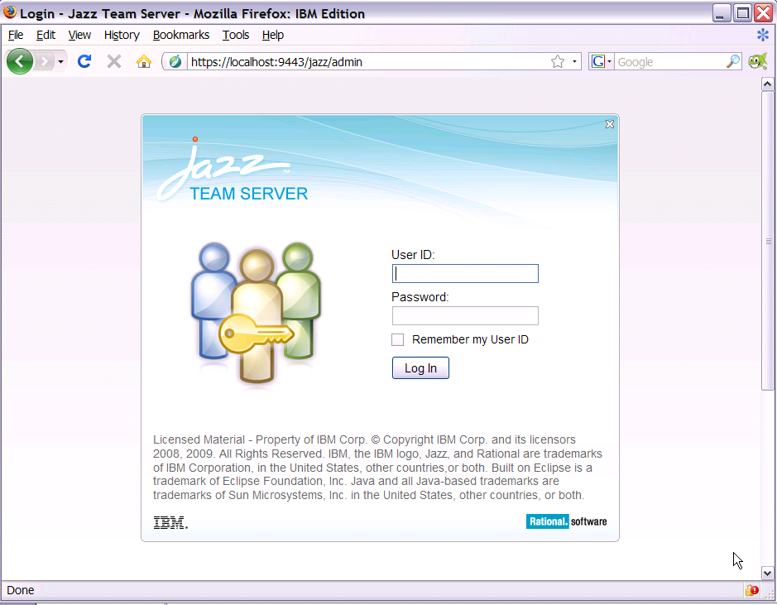

Log in with ADMIN ADMIN

You arrive on this page:
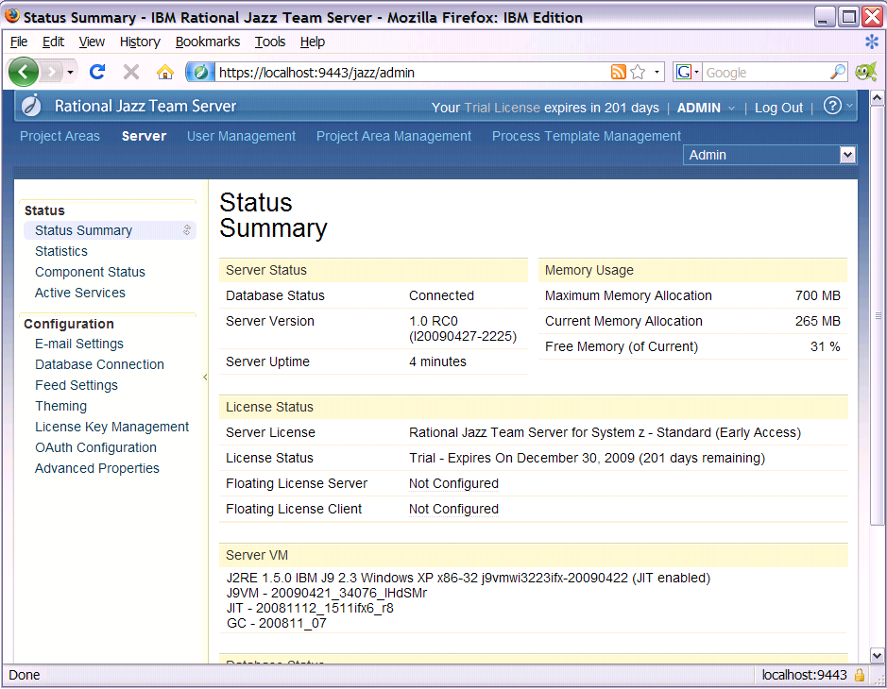

Click on “Advanced properties”

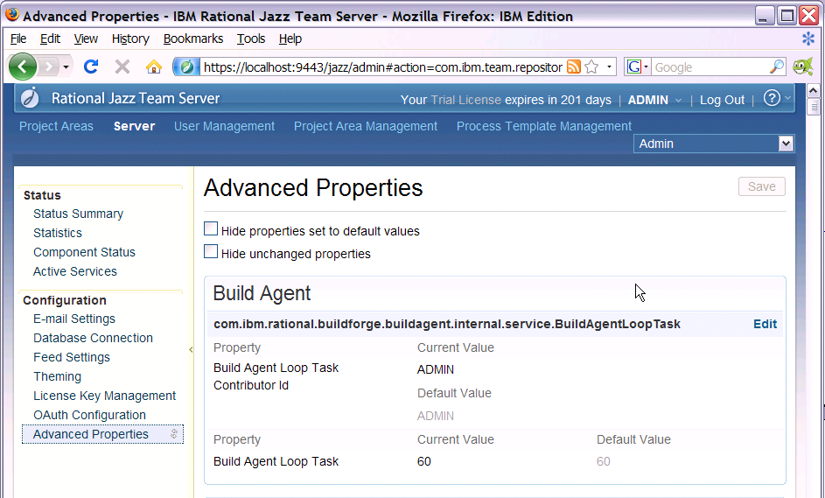

Go to the section PDP repository properties:

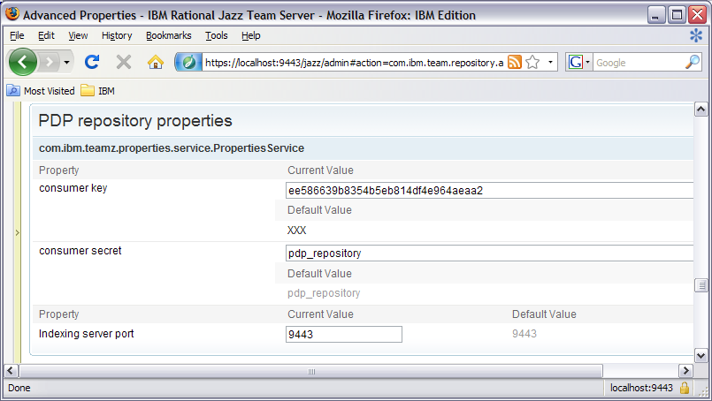

Copy in the Clipboard the consumer key.
Return in your RDz environment, and select the Window->Preferences menu to open the preferences window.

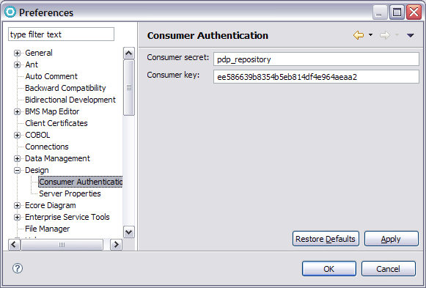

Expand the “Design” item in the left column, and then select the “Consumer Authentication” item.
The opened pane allows you to indicate the consumer key. Paste in the appropriate field the consumer key that you have obtained from the server.

Click the “Apply” button to save this key.

Now, click on the “Server Properties” item.

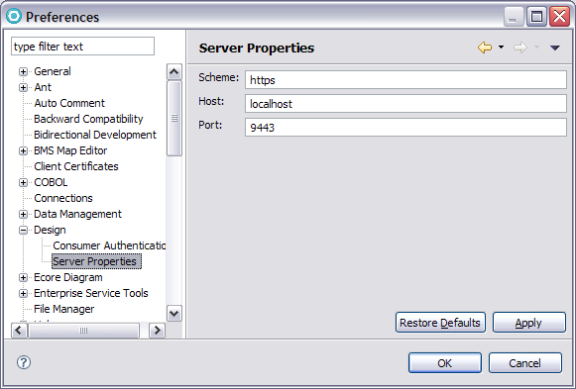

Indicate the appropriate host and port.

Congratulations, your client is now configured!!!!

Make a deliver

Prerequisite 1
You have defined a repository connection (see the “Work Items” perspective).

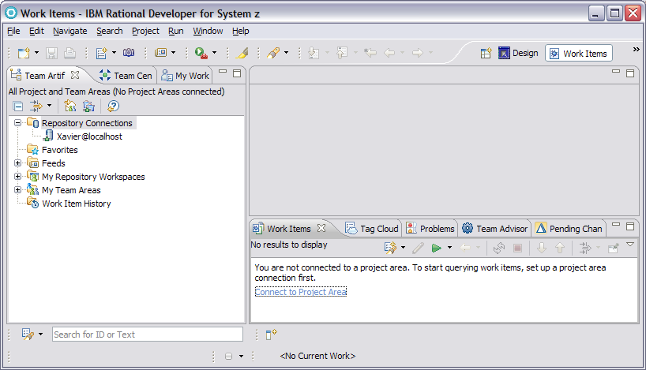

Prerequisite 2

You have in your local workspace a PDP location that contains your PDP model instances (data elements, segments, data structures, etc…). These instances were created manually or imported.

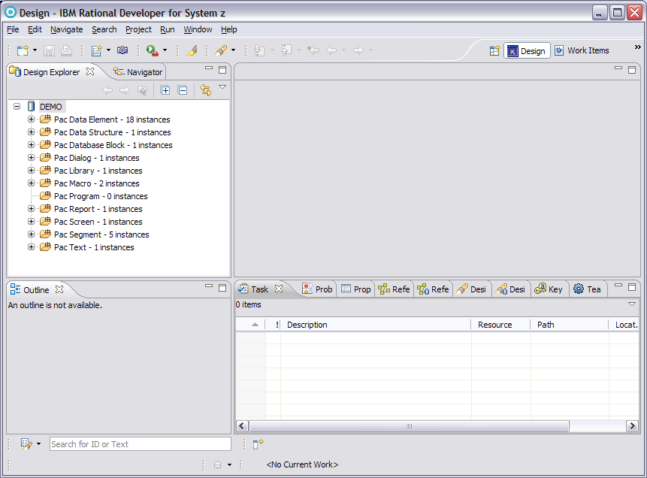

Deliver
To make a deliver of these artifacts, you must go to the navigator view. Click on the “Navigator” pane, in the top-left region of your environment.

This view shows you the projects in which the location DEMO is distributed.

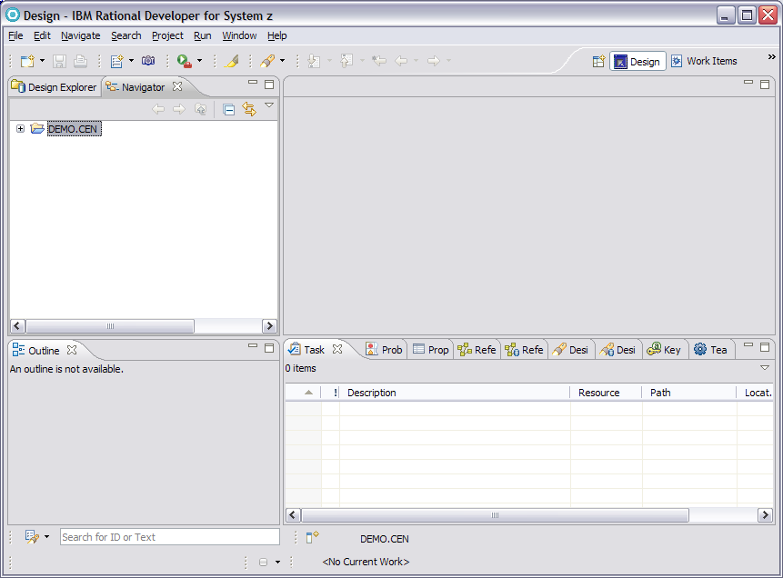

First of all, you must share this project in a repository workspace.

With the right click on the project, select the “Team” menu, and the “Shared Project…” sub-menu.

Select “Jazz Source Control” in the opened dialog.
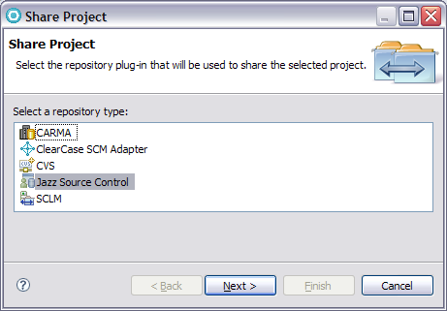
Then, click “Next”…

Select a component in which you want to ‘check-in’ your project.
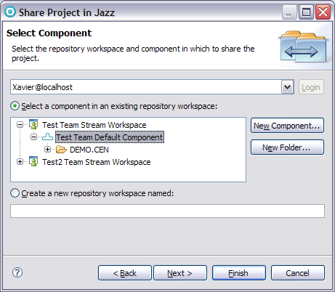
Then “Finish”

In the “Pending Changes” view (in the bottom-right region of your environment), the list of artifacts to ‘check-in’ is displayed.
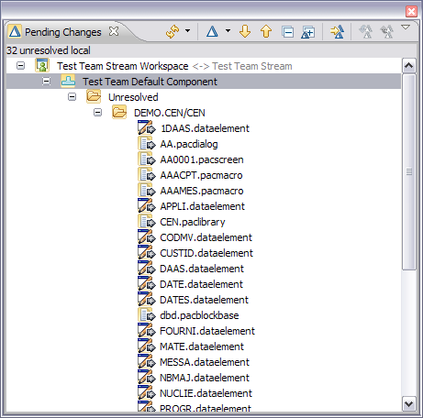

Select the set of artifacts you want to ‘check-in’: the project “DEMO.CEN” for example.
With the right-click on this project, select the “Check-in” menu, “New Change set” sub-menu.

Your local workspace is now synchronized with your repository workspace.

The “Pending Changes” view displays now the deltas between the repository workspace and the RTCz server.
These deltas can be delivered.

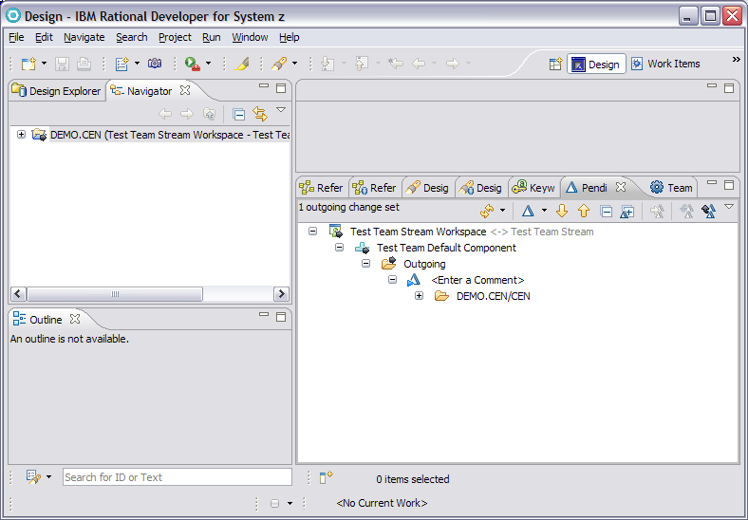

Enter a comment to identify the deliver.

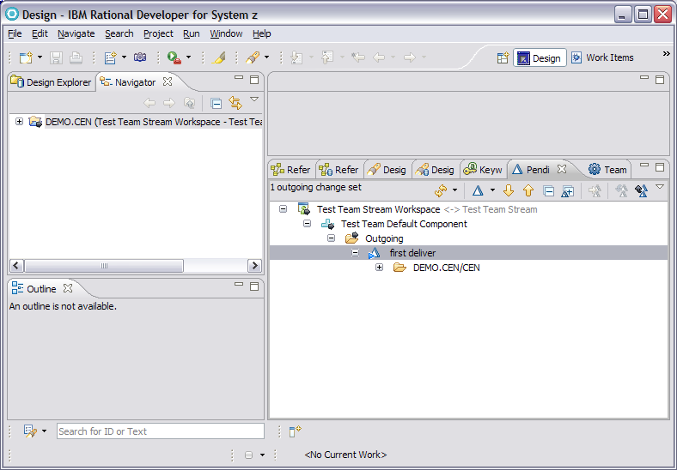

Select the item “Outgoing” with the right click, and select the “Deliver” menu.

Congratulations!!!!… You have delivered a project.

At this step:
All your artifacts are stored in the RTCz server. They are accessible by another user,
A resource containing PDP indexes is associated to each artifact.

We can see two immediate applications based on the set of resources containing PDP indexes:
Search on the RTCz server,
Browse the artifacts via their reference relations.

Search on RTCz Server

Select the “Search” menu, “Search…” sub-menu and open the Search dialog.
Select the “Design RTCz Server Search”.

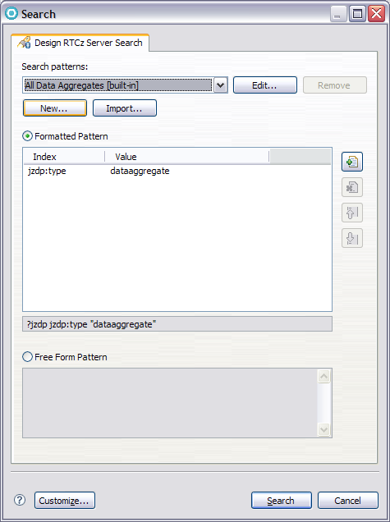

Insights
Some explanations now.

The search on RTCz server is based on patterns. A list of ‘built-in’ patterns (i.e. predefined patterns) is provided. You can add your own customized patterns to this list.
The list of available patterns (built-in and customized) is displayed in the combo-box at the top of the dialog.
You can launch a search from an existing pattern, or you can customize an existing pattern. You have two ways to define a pattern from an existing pattern:
Formatted: it is the simplest way.
The pattern is displayed with its formatted expression. The list of criteria is combined with the ‘AND’ operator.A criteria is defined with an (index, value) pair.
The list of available indexes is displayed in the row cell with a combo-box. The value can be set in the row cell with an edit.
You can add/remove criteria.
The free-form expression of a formatted pattern is displayed in the read-only edit under the row table. It’s a basic tutorial to define a free from pattern.

Free form:
The pattern is displayed with its free form expression. The syntax of this expression is the syntax of a SPARQL query. This kind of expression allows you to define a pattern with a complex combinations of criteria….’AND’, ‘OR’, etc… operator. (‘OR’ operator corresponds to the UNION token in a SPARQL query).

With the pattern shows above, the list of existing Data Aggregates (i.e. segment in the Pacbase terminology) is extracted from the RTCz server.

Search

Click on the “Search” button. You see the result of the search displayed in the “Design RTCz Server Search” view (bottom-right region of your environment).

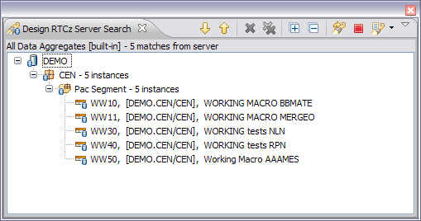

You can obtain this list even if your local workspace is empty.

Browse artifacts via reference relationships

Open the “Design” perspective and active the “Design Explorer” pane in the top-left region of your environment.

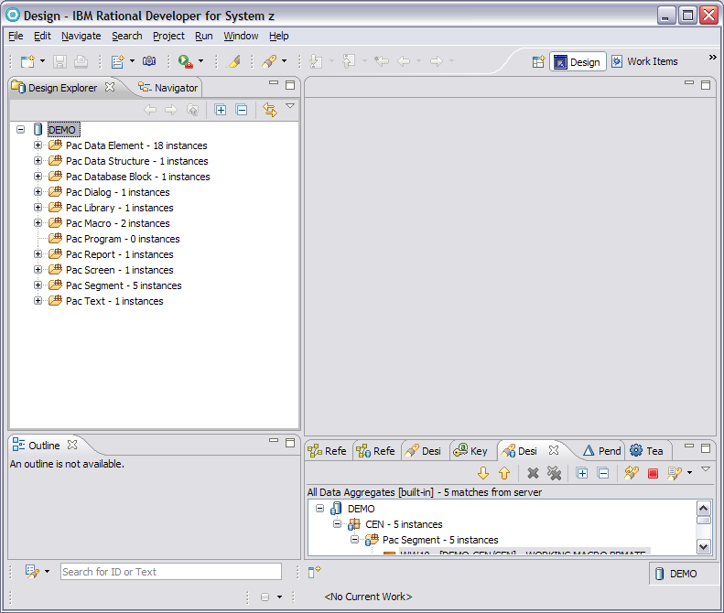

You can see all the artifacts existing in your local workspace.

Select a segment with a right-click, and select the “References” menu, “Server Sub-references” sub-menu.

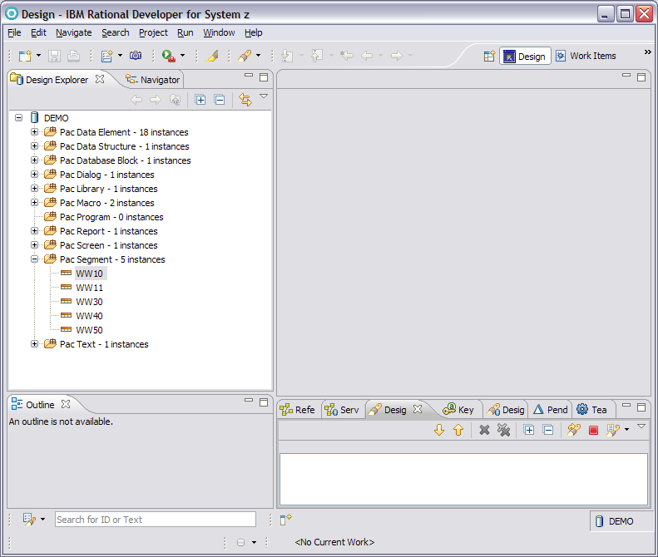

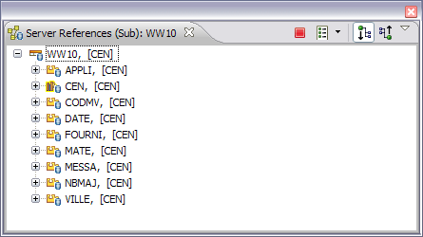

The list of artifacts that the segment references is displayed in the “Server References” view in the bottom-right region of your environment.
You can expand each displayed artifacts, to browse recursively their sub-references.

You can repeat this operation with the “Server Super-references” sub-menu.
You can also switch between sub-references and super-references with the buttons and

