WebSphere Studio V5 Tutorial Demos Handbook
Bill Hahn’s Guided Tour of WSStudio
(Updated 2003/01/27) (Newest material at http://www.WebSphereCentral.com)
(Click here if you need a more recent version of this document)


How to use this Handbook:
- Save this PDF document to your hard drive (important).
- Use the TABLE OF CONTENTS to go directly to any demo description/download.
- Use the “Download Demo First” link, found in the demo description, to start the download.
- If you save each demo in the same folder as this PDF document, you can use the “Run Demo” links to run each demonstration. (That effectively makes this document both a Handbook and a Menu System)

How to get a free CD of demos #1-20 (a.k.a. V5AD#1 - V5AD#20):
- If you are a customer (starting in February 2003) you may order the “Tools for the Enterprise” CD set at the following link: http://www.ibm.com/websphere/enterprisetools (This includes other valuable material as well)
- If you are an IBM employee, go to: http://w3.demopkg.ibm.com or http://w3.demopkg.ibm.com/LPage/DCLI
- Anyone can get a ZIP file of the CD image by clicking here. (unzipping and burning that on a new CD works.)

How the Tutorial Demos are organized:
- Guided Tour (Comprehensively highlights WSStudio V5)
- End-2-End Scenario (Builds an application from scratch that spans J2EE and Web Services building blocks)
- CodePro Studio (Extends WSStudio’s core productivity)
- WSStudio Collection (Existing and under-construction Tutorial Demos)

TABLE OF CONTENTS
(Click to go to a demo)
Quick Comprehensive Tour 5
V5AD#1 The Essence of WebSphere Studio V5 (5 min play time) 5
V5AD#2 Introduction and Tour of WebSphere Studio V5 (30 min play time) 5

Guided Tour (9 Tutorial Demos) 6
The Workbench 6
V5AD#3 Getting Started (5 min play time) 6
V5AD#4 Perspectives and Views (15 min play time) 6
V5AD#5 Keyboard Shortcuts (5 min play time) 6
V5AD#6 Editors (16 min play time) 6
V5AD#7 Multiple Workbench windows enhance navigation (4 min play time) 6
Dynamic Development (Incremental Build, Test, Smart-publish and Hot-Redeploy) 7
V5AD#8 Dynamic Development (10 min play time) 7
On Demand Code Smarts 7
V5AD#9 Java Development using On Demand Code Smarts (25 min play time) 7
Struts Builder Tools 7
V5AD#10 Struts-config.xml editor, Visual Builder & Web Structure View (22 min) 7
Java Visual Editor (JVE) for Thick Clients 7
V5AD#11 Java Visual Editor (JVE) *brief* Introduction (1 min play time) 7
Eclipse 2.0 7
V5AD#12 Eclipse 2.0 Highlights by Rick Weaver (50 min play time) 7

End-2-End Scenario (8 Tutorial Demos) 8
V5AD#13 Introduction to the End-2-End Scenario (1 min) 8
V5AD#14 End-2-End: JSP Web Page and JavaBean (13 min) 8
V5AD#15 End-2-End: JavaBeans in separate Java Project (Java Utility Jars) (8 min) 8
V5AD#16 End-2-End: Session EJB (10 min) 9
V5AD#17 End-2-End: Web Services (10 min) 9
V5AD#18 End-2-End: EJB 2.0 Container Managed Persistence (CMP) (15 min) 9
V5AD#19 End-2-ENd: EJB 2.0 Message Driven Bean (MDB) (3 min) 9
V5AD#20 End-2-End: Transfer Funds (10 min) 9

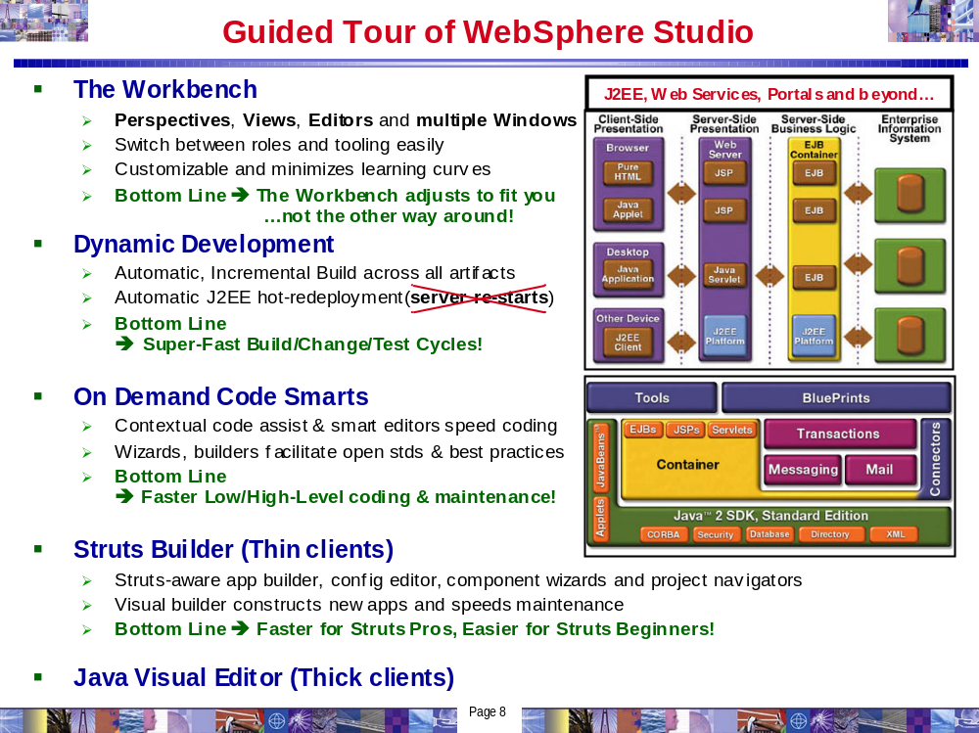
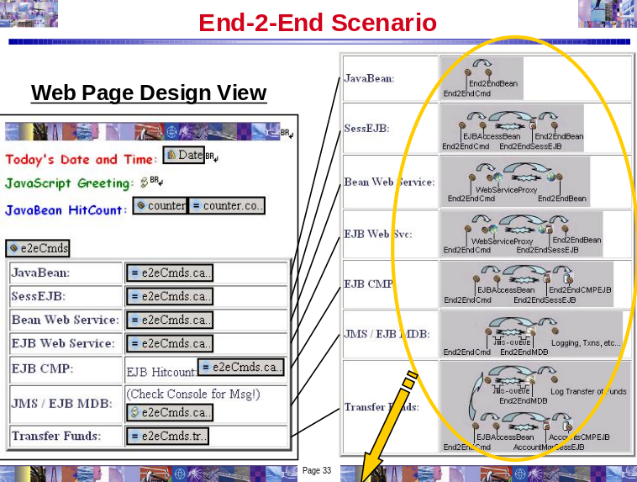
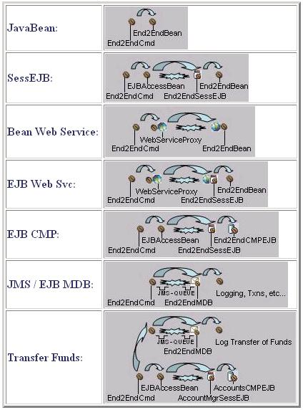
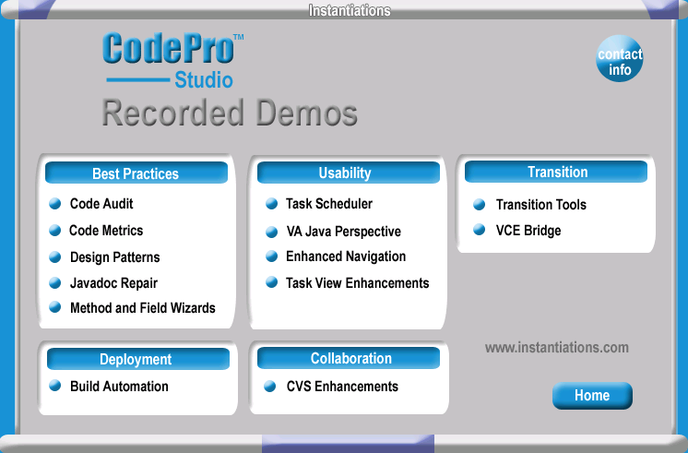
The “Evolving Collection” of Tutorial Demos spans editions of WSStudio, the WebSphere Platform, ISVs and open source plug-in innovations (>100 in 2002). To site one important part of that picture, here is the breadth and depth of the WebSphere Software Platform:
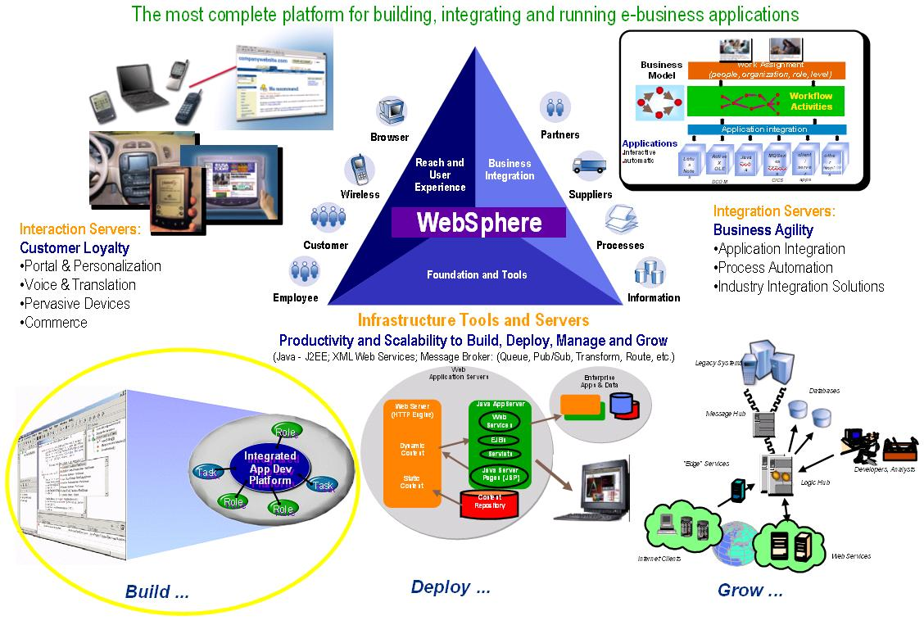

Quick Comprehensive Tour

How to navigate around the Tutorial Demos:
The playback controls make it easy to navigate throughout the demos:
[Spacebar] | Pause / Resume
While Paused: [PgDn] / [PgUp] | Fast Forward / Reverse
[Esc] | Fast slider bar mouse control
[Alt] + [Enter] | Fullscreen mode

V5AD#1 The Essence of WebSphere Studio V5 (5 min play time)
Click here ➔ Download Demo First then Run Demo
This 5 minute presentation introduces you to the building blocks of WebSphere Studio. The breadth and depth of WebSphere Studio extends across Java, J2EE, Web Services, Workflow, Business Integration, the Mainframe and beyond.

V5AD#2 Introduction and Tour of WebSphere Studio V5 (30 min play time)
Click here ➔ Download Demo First then Run Demo
This comprehensive tour includes highlights of WSStudio Application Developer (WSAD). This introductory demonstration is for everyone. While it is designed for developers, it has enough wide-reaching coverage that even non-programmers should find it illuminating. This demonstration will give you an idea of the power, flexibility, breadth and depth of WebSphere Studio. Here are some of the highlights:
- The Workbench
- Java/J2EE, Web Services, XML/XSL, JSP/HTML, Database, Testing and Performance Profile tools are in the same IDE. This enables extremely quick development/test cycles without manually publishing, repeatedly deploying or constantly re-starting application servers.
- “Perspectives”, “Views” and smart editors facilitate roles-based development and leverage a variety of tools. Learning curves are minimized using cleanly organizing activities in a highly customizable IDE. The bottom line: The workbench adjusts to fit you, not the other way around. (i.e. Java, Web, J2EE, HTML/JSP, EJB, XML, Web Services, Profiling, Testing, etc.).
- Developer preferences for workbench and UI are extremely customizable and re-usable across teams.
- The J2EE fabric of WebSphere Studio automatically and incrementally packages your application for quick testing, debugging and deployment. EAR files, JAR files, WAR files and associated deployment descriptors are automatically generated and optionally easily modified.
- Dynamic Development
- Hot-redeployment to local/remote application servers makes multi-tier testing quick, easy and consistent.
- Dynamic round-trip testing leverages Hot-redeploy, incremental compilation/parsing/validation, integrated J2EE test servers, auto-incremental “Smart-Publishing” and code-assist.
- On Demand Code Assist
- Code assist now completes your coding statements for Java, HTML, JSP, TagLibs, XML, XSL, SQL, etc.
- Context sensitive smart editors and builders promote high/low-level coding and best practices
- Struts Builder Tools
- Java Visual Editor (JVE) for Thick Clients

Guided Tour (9 Tutorial Demos)

How to navigate around the Tutorial Demos:
The playback controls make it easy to navigate throughout the demos:
[Spacebar] | Pause / Resume
While Paused: [PgDn] / [PgUp] | Fast Forward / Reverse
[Esc] | Fast slider bar mouse control
[Alt] + [Enter] | Fullscreen mode

The Workbench

V5AD#3 Getting Started (5 min play time)
Drag and drop documents and programming artifacts into WSStudio. WSStudio incrementally builds/compiles/parses/validates artifacts imported and/or drag-dropped into WSStudio. Windows applications, like Word and PowerPoint, run inside WSStudio. This Tutorial Demo begins to acclimate you to how the workbench works and also shows you how you might bring your existing code into WSStudio.
Click here ➔ Download Demo First then Run Demo

V5AD#4 Perspectives and Views (15 min play time)
WebSphere Studio uses a wide variety of dynamic Views to facilitate roles-based development. These Views are customizable and can be combined into customized Perspectives, which are collections of Views. WSStudio comes equipped with a variety of default perspectives. Some popular Perspectives are covered in this demo while others are covered in the “Introduction and Tour” demo (V5AD#2). This demonstration will prepare you to work with the default Perspectives as well as customize and share ones that you can tailor to meet your specific needs.
Click here ➔ Download Demo First then Run Demo

V5AD#5 Keyboard Shortcuts (5 min play time)
Mouse aerobics are desirable in some cases while keyboard shortcuts are otherwise preferred. WSStudio V5 has added many flexibilities to cruise around using the keyboard, as well as a nice summary of those shortcuts in the help system.
Click here ➔ Download Demo First then Run Demo

V5AD#6 Editors (16 min play time)
There are many different “smart” editors in WSStudio. You can use your own favorite editor against any file, seamlessly leveraging the smart-publish and hot-redeploy features of WSStudio that result in dramatically faster test cycles. In addition, the built-in editors adapt to the type of artifacts you are editing by using code-assist, incremental build, colors, highlights, tree views, graphics and many other tactics. This tutorial will familiarize you with the possibilities and teach you the fundamentals of many of the key editors.
Click here ➔ Download Demo First then Run Demo

V5AD#7 Multiple Workbench windows enhance navigation (4 min play time)
V5 introduces the ability to run multiple instances of the Workbench window (Window > New Window). This results in an excellent usage-pattern for cleanly organizing your desktop, without running multiple copies of an IDE and without having too many files crowding your vision. This tutorial will familiarize you with when and how to leverage the multiple workbench window capability of WSStudio V5. (Special note: If you are familiar with WSStudio V4, this is a MUST SEE Tutorial Demo)
Click here ➔ Download Demo First then Run Demo

Dynamic Development (Incremental Build, Test, Smart-publish and Hot-Redeploy)

V5AD#8 Dynamic Development (10 min play time)
Automatic, incremental Build/Compile/Parse/Validate/Publish/Hot-redeploy DRAMATICALLY quickens your development cycle. This tutorial takes that to the extreme and covers the majority of the day-in-the-life-of-a-developer scenarios where this feature saves you a ton of time! (informal customer estimates range from 2-4hrs per day in time savings)
Click here ➔ Download Demo First then Run Demo

On Demand Code Smarts

V5AD#9 Java Development using On Demand Code Smarts (25 min play time)
Code-assist, Code-fix Proposals, incremental Build/Compilation/Parsing, source code wizards, refactoring, templates and the get-me-out-of-a-jam Local History combine to make this coding exercise truly enriched. This tutorial will familiarize you with some of the code productivity features in WSStudio V5 that will save both the low-level and high-level developer a ton of time.
Click here ➔ Download Demo First then Run Demo

Struts Builder Tools

V5AD#10 Struts-config.xml editor, Visual Builder and Web Structure View (22 min play time)
The Struts tooling in V5 is a BIG addition. Both Struts pros and Struts beginners will be able build new Struts apps and maintain existing Struts apps quicker and easier. This tutorial familiarizes you with the WSStudio “Triad” of Struts Tools and takes a very common path through the tools while developing a new Struts application.
Click here ➔ Download Demo First then Run Demo

Java Visual Editor (JVE) for Thick Clients

V5AD#11 Java Visual Editor (JVE) *brief* Introduction (1 min play time)
The JVE is a new addition to V5, it has a critical mass of capability and there are many enhancements slated for this key component. This tutorial will scratch the surface by showing you the primary layout of the JVE editor and it’s hallmark two-way editing capability.
Click here ➔ Download Demo First then Run Demo

Eclipse 2.0 by Rick Weaver (Core IDE enhancements found in WSStudio V5.0)
V5AD#12 Eclipse 2.0 Highlights by Rick Weaver (50 min play time)
Rick Weaver, IBM Sr. Consulting WW Tools Specialist, details the most compelling enhancements.
Click here ➔ Download Demo First then Run Demo

End-2-End Scenario (8 Tutorial Demos)
Silent – NO sound! Smaller files, shorter downloads and quicker coverage.
Narrated versions added soon.

How to navigate around the Tutorial Demos:
The playback controls make it easy to navigate throughout the demos:
[Spacebar] | Pause / Resume
While Paused: [PgDn] / [PgUp] | Fast Forward / Reverse
[Esc] | Fast slider bar mouse control
[Alt] + [Enter] | Fullscreen mode

How the End-2-End Scenario is organized:
- This application is built from scratch.
- Please review the diagram towards the beginning of this document, which uses pictures to describe the breadth and depth of the “End-2-End Scenario”.
- A single JSP is used to invoke multiple methods on a single End2EndCmds.java bean.
- Each method on the End2EndCmds bean calls a different J2EE or Web Services technology. In this fashion, we cover most scenarios with one example.
- The following tutorial demos cover each interaction separately.

V5AD#13 Introduction to the End-2-End Scenario (1 min)
This Tutorial Demo Series is initially offered as a silent (NO sound) edition, resulting in faster downloads and a quicker, more streamlined tour. If you view the “Guided Tour” series first, your familiarity with WSStudio V5 will allow you to follow these tutorials closely and easily. In addition, don’t forget about the playback controls shown in the table above. The playback controls will prove especially useful for your viewing efficiency.
Click here ➔ Download Demo First then Run Demo

V5AD#14 End-2-End: JSP Web Page and JavaBean (13 min)
Create a Web Project, web page (JSP) and JavaBean from scratch. Drag-drop the JavaBean onto the web page and call it directly. Perform some dynamic Hot-redeploy testing. This is the user interface and controller for the End-2-End reference application.
Click here ➔ Download Demo First then Run Demo

V5AD#15 End-2-End: JavaBeans in separate Java Project (Java Utility Jars) (8 min)
It is very common to structure application code across different J2EE building blocks. Specifically, this tutorial demo covers the case where Java classes are in a separate Jar, which is easily developed and integrated in WSStudio using Java Projects. Special Note: For WSStudio V4 enthusiasts, V5 has a new integrated alternative to the V4 vintage “zipcreation” plugin. The “zipcreation” plugin still works with V5 and is a fine alternative if that’s what you are more comfortable using. In addition, the “zipcreation” plugin is more appropriate and necessary in V5 if you are planning to use a non-IBM application server for WSStudio integrated testing (i.e. www.genuitech.com WebLogic plugin).
Click here ➔ Download Demo First then Run Demo

V5AD#16 End-2-End: Session EJB (10 min) >>>Updated 2003/01/20<<<
It is quick and easy to create EJBs of all types in WSStudio. This tutorial focuses on Session EJBs. To make it more interesting, we inherit from an existing plain-old Java class and create a handy EJB Access bean to make it easier to code to the remote EJB. In summary, this is a good example of typical EJB Session EJB creation and coding. Note: The EJB Test Client is very powerful and not used in this Tutorial Demo. Existing V4 Tutorial Demos provide examples of this and new V5 Tutorial Demos will revisit this in the future.
Click here ➔ Download Demo First then Run Demo

V5AD#17 End-2-End: Web Services (10 min)
Web Services development is covered in a first class fashion with WSStudio. WSStudio creates and consumes Web Services, including a newly integrated UDDI “yellow pages” directory and a flexible UDDI browser. Without writing any code, WSStudio can make JavaBeans, EJBs, DB queries and URLs into Web Services. Your Web Service is automatically packaged and hot-deployed for immediate testing. All the necessary artifacts are created and packaged including the WSDL, deployment descriptor, Java Proxy and a sample application for convenient unit testing. Finally, UDDI is integrated inside and outside WSStudio. In this tutorial demo, an EJB is Web Service enabled. Other Web Services scenarios will be covered in the future, especially as additional AXIS support is introduced to compliment WSStudio’s currently AXIS-ready environment.
Click here ➔ Download Demo First then Run Demo

V5AD#18 End-2-End: EJB 2.0 Container Managed Persistence (CMP) (15 min)
WSStudio has first-class object/relational (O/R) mapping. CMP EJBs can be created bottom-up, top-down and meet-in-the-middle. Foreign key relationships in the database(s) are generated into EJB associations for complete persistent navigation. Quick development and full-cycle testing is completed in this tutorial demo. Templates are used to speed the coding effort and a Session EJB acts as a façade to the CMP.
Click here ➔ Download Demo First then Run Demo

V5AD#19 End-2-ENd: EJB 2.0 Message Driven Bean (MDB) (3 min)
MDB development is complete and quick in WSStudio. The integrated WebSphere Application Servers (WAS) in WSStudio are pre-configured, out-of-the-box, with an “MQ for Java Developer” (MQJD) runtime. Therefore, no additional messaging runtime installation is needed to facilitate JMS activities. In addition, configuring JMS providers, Queues/Topic information, listener ports, etc. is easy inside WSStudio. This tutorial demo goes through the steps necessary to create an MDB and then references a comprehensive article that describes a complete exercise, including the JMS/Queue related one-time configuration that is necessary for MDB development/testing. This excellent article is found on WebSphere Developers Domain (WSDD), in the “How-To Resources” on WebSphereCentral.com and a direct link is included (Click Here).
(Please note: While this article introduces the ability to use the administrative console against the WAS test servers in WSStudio, this is an optional step and is only included for academic reasons. All configuration for JMS setup can be done easily within WSStudio)
Click here ➔ Download Demo First then Run Demo

V5AD#20 End-2-End: Transfer Funds (10 min)
This exercise re-uses the EJB Project/Jar from the WSStudio V4 Tutorial Demo “Banking Scenario”. Therefore, this demonstrates a J2EE 1.3 Web Application calling a J2EE 1.2 EJB 1.1 Session/CMP EJB Module, all of which is running as an EAR (application) inside a WAS V5 server. If you would like additional details on how the transfer funds Accounts CMP EJB and AccountMgr Sess EJBs were built, please review the WSStudio V4 “Banking Scenario”. In the future, we will be replicating that scenario in this V5 Tutorial Demo Series.
Click here ➔ Download Demo First then Run Demo

